MARVELLOUS ISIJOLA

DATA ANALYTICS

Table of Contents

* WHAT IS DATA ANALYTICS?
* The DIFFERENCE BETWEEN DATA ANALYTICS AND DATA ANALYSIS
* WHAT TOOLS ARE USED IN DATA ANALYSIS?
* WHY DATA ANALYSIS AND HOW DOES IT COMPARE TO ANOTHER POPULAR PART OF TECH BEING GAME DEVELOPMENT?
* WHAT DOES IT TAKE TO BE A DATA ANALYST?
* PROGRAMMING IN DATA ANALYTICS
* WHAT ARE SOME COMMON CHALLENGES FACED BY DATA ANALYSTS? (FAQ)
* CAN ANYONE BECOME A DATA ANALYST? (FAQ)
* DOES DATA ANALYTICS REQUIRE CODING? (FAQ)
* WHAT IS THE DIFFERENCE BETWEEN A DATA ANALYST AND A DATA SCIENTIST? (FAQ)
* IS DATA ANALYTICS MATH-HEAVY? (FAQ)
* CONCLUSION
* FACTS ON DATA ANALYSIS
* REFERENCES

## WHAT IS DATA ANALYTICS?

Data analytics to begin with is the inspecting and studying of data to find patterns and therefore make more educated decisions. For example, this would help a restaurant know which of their menu items sell more and buy ingredients according to what items generate more sales in order not to lose money. Data analytics can prevent loss of money and failed investments, it advises companies on what move to make next. There are five types of data analytics:

* Predictive Data Analytics -Predictive analytics may be the most commonly used category of data analytics. Businesses use predictive analytics to identify trends, correlations, and causations. The category can be further broken down into **predictive modeling** and **statistical modeling**; however, it’s important to know that the two go hand in hand. For example, an advertising campaign for t-shirts on Facebook could apply predictive analytics to determine how closely conversion rate correlates with a target audience’s geographic area, income bracket, and interests. From there, predictive modeling could be used to analyze the statistics for two (or more) target audiences and provide possible revenue values for each demographic.
* Prescriptive Data Analytics - Prescriptive analytics is where AI and big data combine to help predict outcomes and identify what actions to take. This category of analytics can be further broken down into **optimization** and **random testing**. Using advancements in ML, prescriptive analytics can help answer questions such as “What if we try this?” and “What is the best action?” You can test the correct variables and even suggest new variables that offer a higher chance of generating a positive outcome.
* Diagnostic Data Analytics - While not as exciting as predicting the future, analyzing data from the past can serve an important purpose in guiding your business. Diagnostic data analytics is the process of examining data to understand cause and event or why something happened. Techniques such as drill down, data discovery, data mining, and correlations are often employed. Diagnostic data analytics help answer why something occurred. Like the other categories, it too is broken down into two more specific categories: **discover and alerts** and **query and drill downs**. Query and drill downs are used to get more detail from a report. For example, a sales rep that closed significantly fewer deals in one month. A drill down could show fewer workdays, due to a two-week vacation.

Discover and alerts notify of a potential issue before it occurs, for example, an alert about a lower number of staff hours, which could result in a decrease in closed deals. You could also use diagnostic data analytics to “discover” information such as the most-qualified candidate for a new position at your company.

* Descriptive Data Analytics - Descriptive analytics are the backbone of reporting—it is impossible to have business intelligence (BI) * tools and dashboards without it. It addresses basic questions of “how many, when, where, and what.” Once again, descriptive analytics can be further separated into two categories: **ad hoc reporting** and **canned reports**. A canned report is one that has been designed previously and contains information around a given subject. An example of this is a monthly report sent by your ad agency or ad team that details performance metrics on your latest ad efforts. Ad hoc reports, on the other hand, are designed by you and usually aren’t scheduled. They are generated when there is a need to answer a specific business question. These reports are useful for obtaining more in-depth information about a specific query. An ad hoc report could focus on your corporate social media profile, examining the types of people who’ve liked your page and other industry pages, as well as other engagement and demographic information. Its hyper specificity helps give a more complete picture of your social media audience. Chances are you won’t need to view this type of report a second time (unless there’s a major change to your audience).

*Business intelligence (BI) is the use of software to combine business analytics, data mining, data visualization, data tools and infrastructure, and best practices to help organizations to make more data-driven decisions.

THE DIFFERENCE BETWEEN DATA ANALYTICS AND DATA ANALYSIS

Data analytics is a general term for a field that includes the entire management of data and the methods and instruments employed. On the other hand, data analysis is the process of dissecting a given data set into its component pieces and analyzing each one separately, as well as how the parts relate to one another.

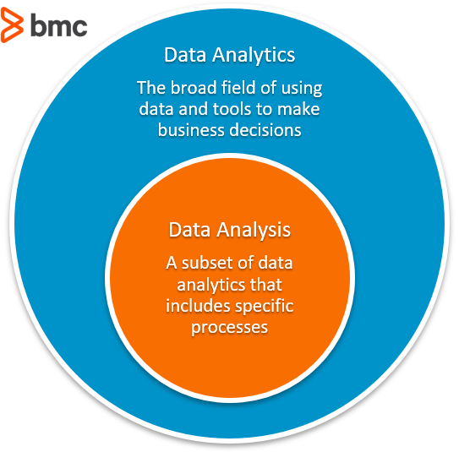

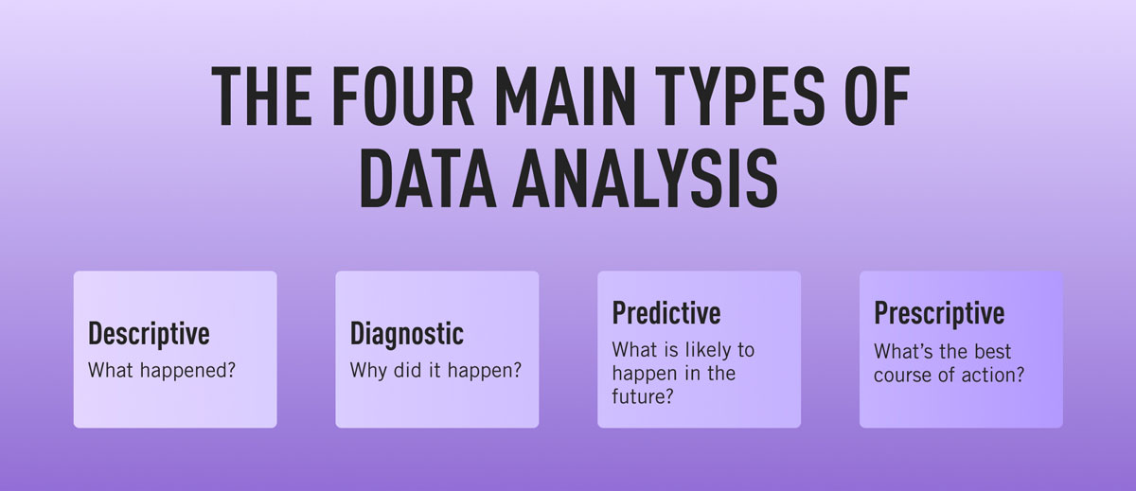

## WHAT TOOLS ARE USED IN DATA ANALYSIS?

To analyze data, you would need tools to manage it, like Excel to sort the data and applications like Access to store databases. You would also need tools to show data like Word and PowerPoint. But aside from these there are applications created with data analytics specifically in mind like Google Cloud, Tableau and Microsoft Azure. To elaborate on tools designed specifically with data analytics in mind, here are deeper definitions of Google Cloud, Tableau and Microsoft Azure:

* Google Cloud - Google Cloud Platform (GCP), offered by Google, is a suite of cloud computing services that runs on the same infrastructure that Google uses internally for its end-user products, such as Google Search, Gmail, Google Drive, and YouTube. Alongside a set of management tools, it provides a series of modular cloud services including computing, data storage, data analytics and machine learning. Google lists over one hundred products under the Google Cloud brand. They are categorized under Computing, Storage and Databases, Networking, Big Data, Cloud AI, Management tools, Identity and security, Internet of things, and API Platform.
* Tableau - Tableau Software is an American interactive data visualization software company focused on business intelligence. Tableau products query relational databases, online analytical processing cubes, cloud databases, and spreadsheets to generate graph-type data visualizations. The software can also extract, store, and retrieve data from an in-memory data engine. The services they provide are:
* Tableau Desktop
* Tableau Server
* Tableau Prep Builder (released in 2018)
* Tableau Vizable (consumer data visualization mobile app released in 2015)
* Tableau Public (free to use)
* Tableau Reader (free to use)
* Tableau Mobile
* Tableau Cloud
* Tableau Prep
* Tableau CRM
* Microsoft Azure - Microsoft Azure, often referred to as Azure is a cloud computing platform run by Microsoft, which offers access, management, and development of applications and services through global data centers. Microsoft Azure supports many programming languages, tools, and frameworks, including Microsoft-specific and third-party software and systems. Microsoft Azure uses large-scale visualization at Microsoft data centers worldwide and it offers more than six hundred services.

Logos for the various applications mentioned:

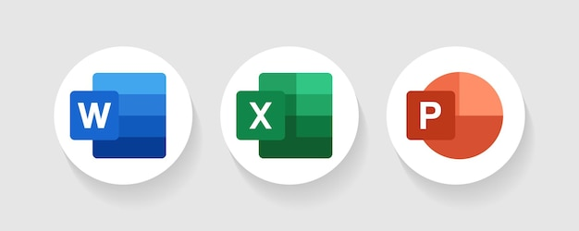

Word, Excel, and PowerPoint, tools that can be used for data analysis amongst other things.



Access is a program created by Microsoft that allows you to store and manage databases.



Google Cloud is the general name for Google’s cloud computing but has software under it that can be used for data analysis.

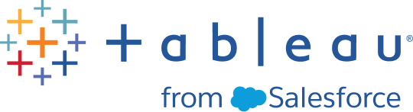

Tableau is a form of software that turns data into reasonable graphs that are much easier to work with.

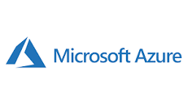

Microsoft Azure is the general name for Microsoft’s cloud computing but has products under it that can be used for data analytics.

WHY DATA ANALYTICS AND HOW DOES IT COMPARE TO ANOTHER POPULAR PART OF TECH BEING GAME DEVELOPMENT?

Data Analytics is a huge industry and is especially useful in companies so there are many jobs related to data analytics open. It is also quite high paying as the ability to manage data is a valuable skill to have. It also leads to better decision making, retention and loyalty, and an increase in the efficiency of work. Game development, however, utilizes your creativity and works on your patience as you will encounter glitches and bugs you will encounter in development.

WHAT DOES IT TAKE TO BE A DATA ANALYST AND WHAT ARE THE REQUIREMENTS?

To be a data analyst requires training that will require a lot of your attention. You will also need to have patience in training to become a data analyst as you will have to study materials to prepare you for that career. According to the testimony of my father who did business analysis training which involves data analysis, he needed to stay up till late at night reading and memorizing all the terms and methods that needed to be memorized because he was juggling that with a full time job, but for someone without a full time job doing this this will still require you to go that extra mile if you even hope of succeeding in this field. To be a successful data analyst, you need strong math and analytical skills. You must be able to think logically and solve problems and have diligence. Additionally, you must be able to effectively communicate your findings to those who will make decisions based on your analysis. Some data analysts have a bachelor’s degree in math, statistics, economics, computer science, or another quantitative field. However, with the right skills and experience, it is possible to become a data analyst without a college education in this area. More employers are also favoring candidates who have earned certifications with a sole focus in data analysis.

PROGRAMMING IN DATA ANALYTICS

In Data Analytics, you can write algorithms that can review sets of data and notice trends in that data and print those results. Programs like that can be written with programming languages like Python, JavaScript, Ruby, and C++. These languages can be used to automate the process of constantly going over sets of code and can be paired with the use of specialized software for data analytics.

WHAT ARE SOME COMMON CHALLENGES FACED BY DATA ANALYSTS?

Data analysts may face several challenges in their work. First, they may need to clean or “wrangle” data sets that are messy or incomplete. Second, they may need to find trends or insights in large data sets, which can be difficult and time-consuming. Third, they may need to effectively communicate their findings to those who make decisions based on their analysis. Finally, data analysts may need to stay up-to-date on new analytical methods and software programs.

### Can anyone become a data analyst?

Having a background in computer science, mathematics, statistics, or related fields may make it easier to become a data analyst, but anyone with the right skills and determination can become a data analyst. The key is to gain proficiency in the necessary technical skills like programming languages (such as Python, R, and SQL), data visualization tools (like Tableau and PowerBI), database management tools, and the ability to analyze and draw insights from data.

Soft skills like communication, problem-solving, and critical thinking are also essential. While formal education in data analysis or a related field can be helpful, many online resources, courses, and boot camps are available for anyone interested in learning data analysis. With dedication and a willingness to learn, anyone can become a data analyst.

Does data analytics require coding?

Yes, data analytics often requires coding skills. While some data analysis tools allow for visual manipulation of data without coding, such as Tableau, Power BI, or Excel, proficiency in programming languages like Python, R, SQL, and Java can be highly beneficial in performing advanced analysis and building custom data models. In addition, knowledge of programming and scripting languages can help automate repetitive tasks and streamline data analysis processes.

What is the difference between a data analyst and a data scientist?

Data analysts and data scientists are both data professionals, but there are some critical differences in their roles, skills, and responsibilities:

* Role: Data analysts primarily work with structured data to derive insights and make data-driven decisions. Data scientists use structured and unstructured data to develop and implement predictive models and algorithms.
* Skills: Data analysts require strong skills in data management, statistical analysis, data visualization, and business domain knowledge. Data scientists need advanced machine learning, programming, and data engineering skills.
* Responsibilities: Data analysts typically focus on data cleaning, data analysis, and reporting, while data scientists focus on developing and deploying predictive models and algorithms that can drive business outcomes.

Is data analytics math-heavy?

Yes, data analytics is a math-heavy field. A solid understanding of mathematics, including statistics, is essential for data analysis. Data analysts need to be able to work with large datasets, use statistical methods to analyze the data and apply mathematical models to interpret the results. They may also need programming languages like Python and R to write and run statistical models and algorithms. While a foundation in math is essential, it's also important to note that data analysts can use various tools and software to help with the heavy lifting, such as Excel, Tableau, and PowerBI.

CONCLUSION

In conclusion, Data Analytics is a thriving industry in which it is not all that hard to succeed especially if you take your training seriously, and to be a data analyst you have to have a specific skill set as well.

FUN FACTS ON DATA ANALYTICS

Netflix is a huge fan of data analytics

Netflix is a company that places a strong emphasis on utilizing data analytics. Predictive analytics is a field that uses current and past data to make predictions through methods such as data mining, machine learning, and predictive modeling. This allows companies to understand their customers better and identify potential risks and opportunities, aiding in decision-making. With the vast amount of data being generated daily, companies are utilizing the power of machine learning algorithms to extract insights from this data. The insights gained through predictive analytics are then used in prescriptive analytics to inform actions and strategies. Also, each year, Netflix leverages big data to achieve savings of $1 billion in customer retention.

EVERY HUMAN CREATED ABOUT 1.7 MB OF DATA PER SECOND LAST YEAR.

Human activity also greatly contributes to the increasing amount of data available for analysis. Each second, the average person generates 1.7 megabytes of information. With over 3.7 billion internet users worldwide, this data generation shows no signs of slowing down.

AROUND 2.5 QUINTILLION BYTES WORTH OF DATA IS GENERATED EACH DAY.

In today's digital age, data is being generated from a wide range of sources, such as social media, online transactions, and sensors in various devices. The number "2.5 quintillions" is a huge quantity and is equivalent to 2,500,000,000,000,000,000 bytes. This staggering amount of data is a testament to the increasing amount of information that is being generated and stored every day.

IT WOULD TAKE 181 MILLION YEARS TO DOWNLOAD ALL THE DATA FROM THE INTERNET.

The internet is a vast network of interconnected computers and servers that store an enormous amount of data in the form of text, images, videos, and other types of digital content. This data is constantly being generated, updated, and added to, making the total amount of information stored on the internet truly massive.   
This estimate serves as a reminder of the vast and ever-growing amount of information that is stored on the internet.

REFERENCES

blueoceanlab.io

jaroeducation.com

datacamp.com

simplilearn.com

oracle.com

online.hbs.edu